PMIJO Speaker form
Meetup Workshop
Contacts (will not placed on the poster)
Mobile | :
Email | :
Poster details
Event Title | :
Event Date / time / duration
Name (as it will be displayed first line) | :
Title (Under the name before the bio) | :
Bio (1,200 characters max with spaces) | :
Highlight of the Event/Webinar (700 characters) | :
Learning Objectives | :
Picture any format (PNG, JPG), clear 292 x 292 pixels (or higher) | : | (please attached it as separate file)
Please make sure that you spell and grammar check your text
Sample:
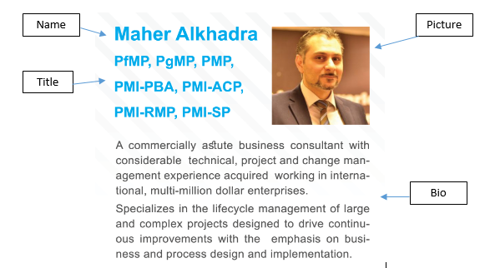

Sample poster

